How to Copy and Paste
This simple instruction involves:
Left click

Right Click
A mouse or a touch pad (see below)

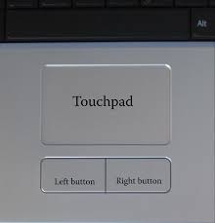

Step 1: Take your mouse or touchpad, and place your cursor at the beginning of the text
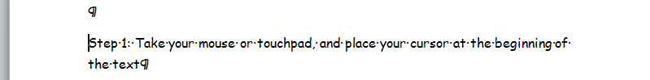
Step 2: then click and hold the left mouse button, while pulling your mouse over the text. This should highlight the text
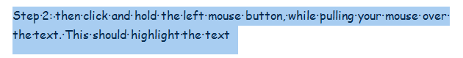
Step 3: Now release the left mouse button.

Step 4: Now, with the cursor over the highlighted text, right click the mouse for options, and select 'copy'
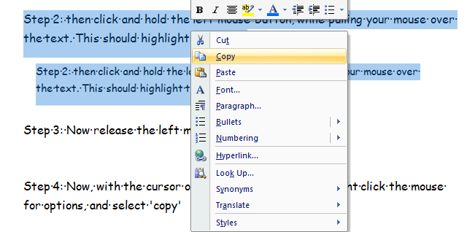

Step 5: right click your mouse again, and select 'paste' and you will have copied and pasted the text. :-)
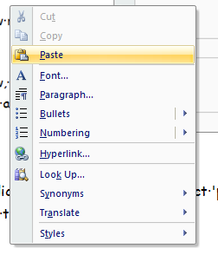
This is copy and paste..so it copy’s it..but you can use cut and paste..But instead of copying it..it cuts-so takes it away and pastes it in a different place.

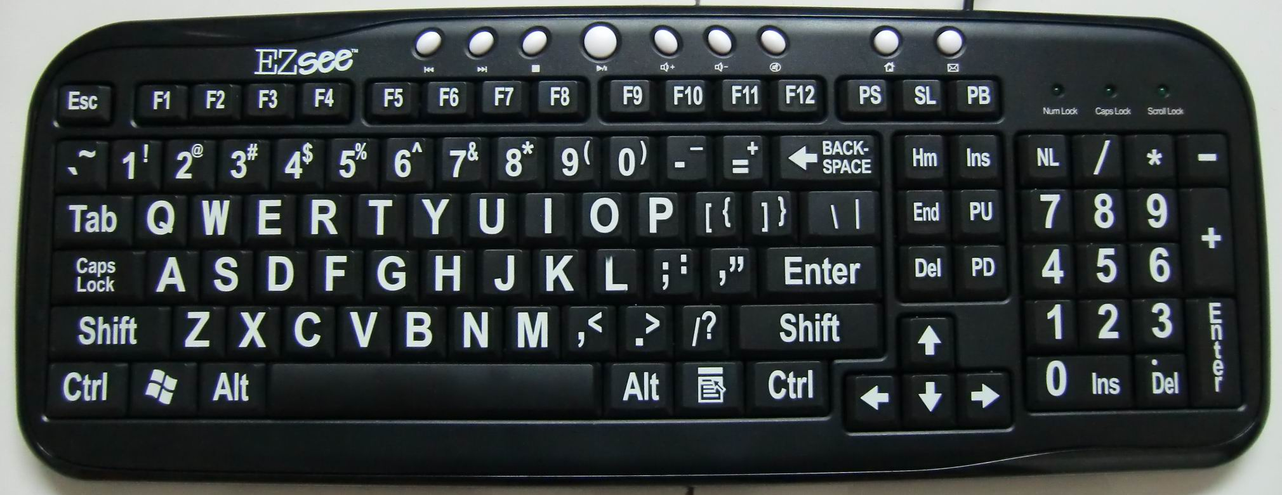
Shortcuts---to highlight text place cursor at the beginning of the text and press ctrl and a at the same time.
To copy press ctrl and c at the same time
To paste press ctrl and v at the same.

